**Exp No 8:**

**Practice Queries using Aggregate functions, Group By, Having Clause and Order by Clause.**

**#count**

select count(attendance) from academic_details

where attendance > 75;

**Output:**

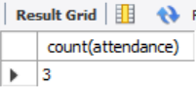

**#Average**

select Avg(OS) from marks;

**Output:**

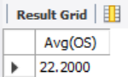

**#min**

select roll_no,min(Dbms) from marks;

**Output:**

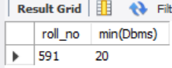

**#max**

select max(OS) as highestmarks from marks;

**Output:**

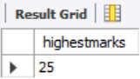

**#sum**

select sum(Befa) from marks;

**Output:**

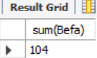

**#group by**

select count(roll_no), OS

from marks group by OS;

**Output**:

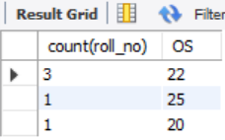

**#having**

select count(roll_no), OS

from marks group by OS

having count(roll_no) > 2;

**Output:**

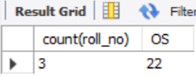

**#order by**

select roll_no,attendance from academic_details

order by attendance desc;

**Output:**

